**CHAPTER FOUR**

**RESULT**

**Systematic review**

**4.1 Literature search**

PubMed, Google scholar, ScienceDirect, Medicine library were search from 1 January 2022 to November 2022, for available publications in line with the search MESH search terms. A total of 317 studies were imported for the screening. The numbers was reduced to 292 after the removal of duplicate of about 25. 292 studies was moved to title and abstract screening, 276 studies are irrelevant base on the title and abstract screening with regard to the inclusion and exclusion criteria. 14 studies were included for the full-text assessed for the eligibility, 14 studies was included for the qualitative study.

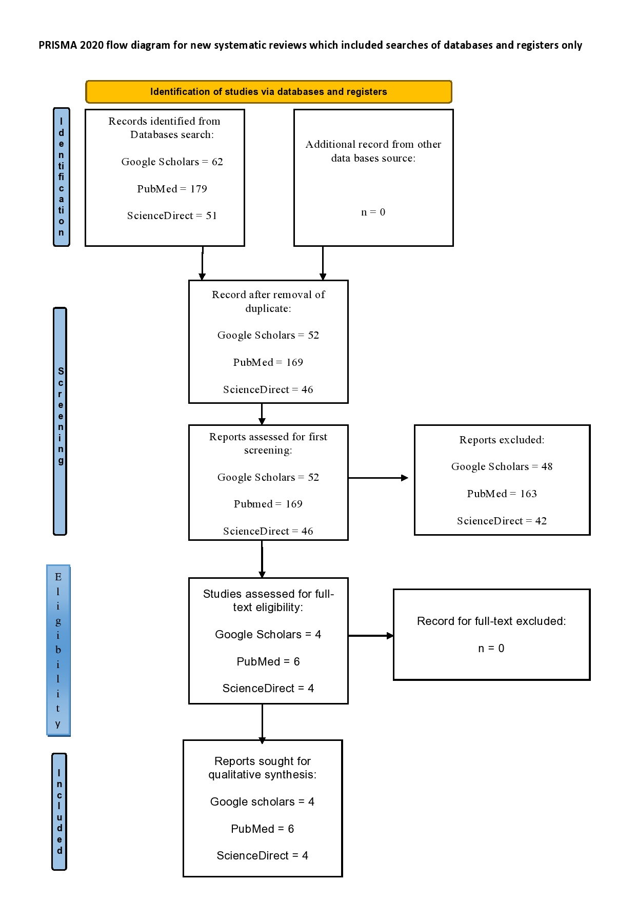

**Figure 4.1** Showing theflow of research from the literature using PRISMA standards. Only 14 of the 317 articles found through database searching met the criteria for inclusion after first and full-text screening and were used in the qualitative analysis and synthesis.

**4.2 Data extraction**

Table 1 lists the findings of the research selection as well as the details of the fourteen papers that were taken into consideration from Google Scholar, PubMed, and ScienceDirect. In 2022, all papers were published. All fourteen researches were carried out in various nations, which includes: China (n=12), Iran (n=1) and Spain (n=1). All the studies include either the prognostic or diagnostic biomarkers for bladder cancer. The main finding of all included studies illustrates the presence of potential biomarker that will assist for the surveillances of bladder cancer treatment. About nine research focused on the prognostic biomarkers (Chi et al., 2022), (Sun et al., 2022), (Jiang et al., 2022), (Ariafar et al., 2022), (Wang et al., 2022), (Zhao et al., 2022), (Hu et al., 2022), (Tang et al., 2022), and (Li et al., 2022). While five studies discussed on diagnostic biomarkers (Yan et al., 2022), (Carrasco et al., 2022), (Huang et al., 2022), (Tan et al., 2022) and (Liu et al., 2022) respectively. The purpose of each biomarker for improvement of bladder cancer management was included in table 1, which the pathways between each study are different. All of the research listed in Table 1 were analyzed and synthesized to establish the consensus for this study.

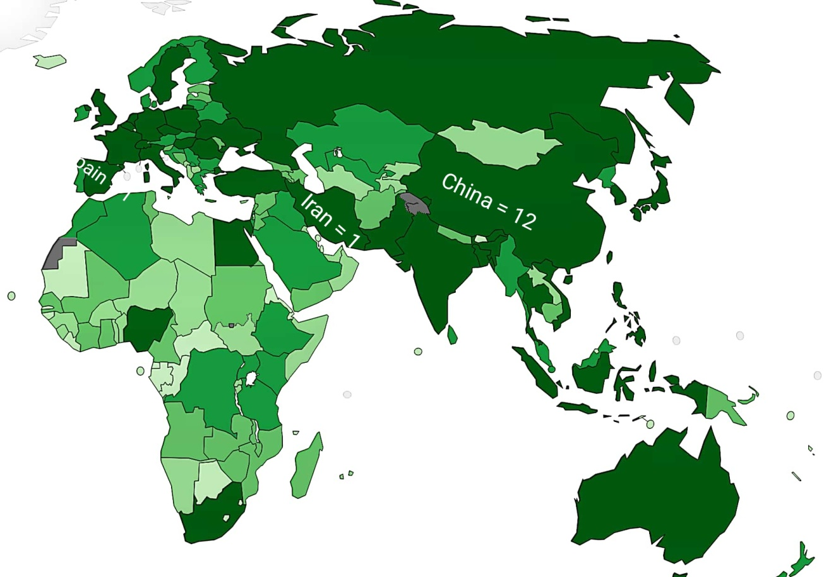

**Figure 4.2:** World map showing the number of studies included from each country: China = 12, Iran = 1, Spain = 1.

|  |  |  |  |  |  |  |
| --- | --- | --- | --- | --- | --- | --- |
| 1 | 2 | 3 | 4 | 5 | 6 | 7 |
| **Author & Year** | **Country** | **Biomarker** | **Sample** | **Source** | **Pathways** | **Purpose** |
| Chi *et al. (*2022) | China | *TEAD4* | Genes | Tissue | P13K/AKT | TEAD4 promotes EMT of BLCA cells by activating the PI3K/AKT pathway, which enhances cell migration and invasion. TEAD4 is a potent predictor of poor prognosis. These results offer a potent target for the treatment of metastatic BLCA in addition to an efficient biomarker for prognosis prediction. |
| Suna *et al.*  (2022) | China | *NXPH4* | Genes | Tissue | immune-related pathways | NXPH4 was discovered by the current investigation to be an unique prognostic molecular marker linked to immune cell infiltration in BCa. These results might open up fresh perspectives on how BCa's prognosis is determined as well as guide future research on BCa's tumor immunity. |
| Jiang *et al.*  (2022) | China | TIPE2 | Proteins | Tissue | Tollike receptor (TLR) and T cell receptor (TCR) signaling pathways. | The characteristics of TIPE2 expression, clinicopathological findings, and prognosis in bladder urothelial cancer were all thoroughly examined in this work. Overall, the findings suggest that TIPE2 may be employed as a biomarker for bladder urothelial cell carcinoma patients' illness prognosis and disease progression. |
| Ariafar *et al.* (2022) | Iran | CD3, CD8,  CD45RO and FOXP3 | Proteins | Tissue |  | In early-progressed malignancies, immune cells, particularly CD45RO+, CD3+, and CD8+ lymphocytes, were much more abundant. Studies have also shown that the prognosis is significantly influenced by the heterogeneity in the tumor microenvironment, even in two patients with the same type of cancer, the tumor microstructure, immune cell distribution in the tumor's center and margin, secondary lymphoid structures, as well as the type of inflammatory cells and their functional status. |
| Yan *et Al .*(2022) | China | TPM1 and TPM2 | Genes | Tissue | immune inhibition | TPM1 and TPM2 are useful diagnostic indicators for bladder cancer. TPM1 is a stand-alone predictor of bladder cancer outcome. The invasion of different immune cells in bladder cancer is also linked to TM. TM may have influenced the development of bladder cancer through immune inhibition. |
| Wang *et al.* (2022) | China | *SKA3* | Genes | Tissue | M2 macrophages and Th2 cells | SKA3 is linked to immune infiltration and can affect a patient's prognosis for bladder cancer. In particular, SKA3 may affect the development of M2 macrophage and Th2 cells, which may aid in the growth and spread of bladder cancer. SKA3 may therefore be an useful prognostic biomarker for bladder cancer. |
| Carrasco *et al.* (2022) | Spain | cfDNA | Genes | Blood | Androgen Receptor Pathway | In MIBC patients who had RC, cfDNA levels and ctDNA status four months later are indicators of tumor growth and CSS, respectively. Additionally, cfDNA monitoring can be used to forecast patients' outcomes following RC.  Since patients might gain from early therapy, the application of cfDNA analysis in the therapeutic setting may have an effect on illness management. |
| Huang *et al.*  (2022) | China | ENOs | Genes | Tissue | glycolysis pathway | ENO1 was substantially correlated with tumor aggressiveness and abnormally overexpressed in BLCA. Upregulation of ENO1 also predicted worse clinical outcomes. These findings suggested that ENO1 could be a useful predictive biomarker for BLCA. Additionally, there was a striking correlation between ENO1 expression and immune cell infiltration in the TME of BLCA. Together, our findings contribute to a deeper comprehension of ENO1's actions as well as its potential translational applications for BLCA diagnosis and treatment. |
| Zhao *et al.*  (2022) | China | KLK6 | Genes | Tissue | neutrophils migration  and chemotaxis | KLK6 is a separate prognostic factor and a target of BLCA's anticancer activity. KLK6 inhibition may help with BLCA immunotherapy because KLK6 expression favorably corresponds with the invasion of various immune cells. |
| Hu *et al.* (2022) | China | lncRNA  (MIR4435-2HG) | Genes | Tissue | Wnt/_Beta-catenin signaling pathway | Finally, we examined the publicly available information from numerous bladder cancer cohorts and discovered that MIR4435-2HG has a considerable predictive significance. Our research offers a fresh perspective on the prediction of bladder cancer, offering new possibilities for experimental research as well as auxiliary markers for clinical use in determining prognosis and creating management plans. |
| Tang *et al.*  (2022) | China | 7 genes (GRHL2, ANXA1, APOL1,  SETBP1, NR2F1, KLRB1 and PLAC9) | Genes | Tissue |  | In conclusion, we identified seven important genes (GRHL2, ANXA1, APOL1, SETBP1, NR2F1, KLRB1, and PLAC9) and created a 7-gene signature predictive model for BC patients using univariate Cox, LASSO, and multivariate Cox analyses. Before it may be effectively used in clinical practice, the 7-gene signature in the BC patient prognostic assessment model still needs more clinical validation. |
| Tan *et al.*  (2022) | China | HSPB8 | Proteins | Tissue | Growth factor binding, peptidase regulatory activity, cytokine binding, proteoglycan binding, complement activation, positive regulation of leukocyte migration, humoral immune response, and peptidase inhibitor activity pathways were all enriched in HSPB8. | HSPB8 may be a promising diagnostic and prognostic molecular marker for BC, according to the current study's findings. But in order to confirm the clinical applicability of HSPB8 in the individualized therapy of BC, substantial prospective studies are needed. |
| Liu *et al.*  (2022) | China | HYAL3 | Genes | Tissue | DCs, mast cells, B cells, T follicular helper cells, interdigitating  DCs, activated DCs, regulatory T cells, cytotoxic  cells, CD8+  T cells, T cells, central memory T cells, and  Th cells. | A shorter OS among BLCA patients may be predicted by a greater HYAL3 expression level. Additionally, in BLCA, HYAL3 was linked to a variety of invading immune cells, including as Th cells, T cells, CD8+ T cells, cytotoxic cells, B cells, etc. These findings suggest that HYAL3 may someday be used as a biomarker for the detection and management of BLCA. |
| Li *et al.*  (2022) | China | PVT1 | Genes | Tissue | P53 signaling  pathway | PVT1 may serve as a new BLCA biomarker and help predict treatment outcomes. PVT1 is a key player in the development and prognosis of BLCA and can be employed as a medium biomarker to predict post-cystectomy survival. |

**Table 1:** Data were taken from and analyzed for each of the fourteen investigations. On 2022, all studies were published. Nine records were on prognostic biomarkers and five were on diagnostic biomarkers.

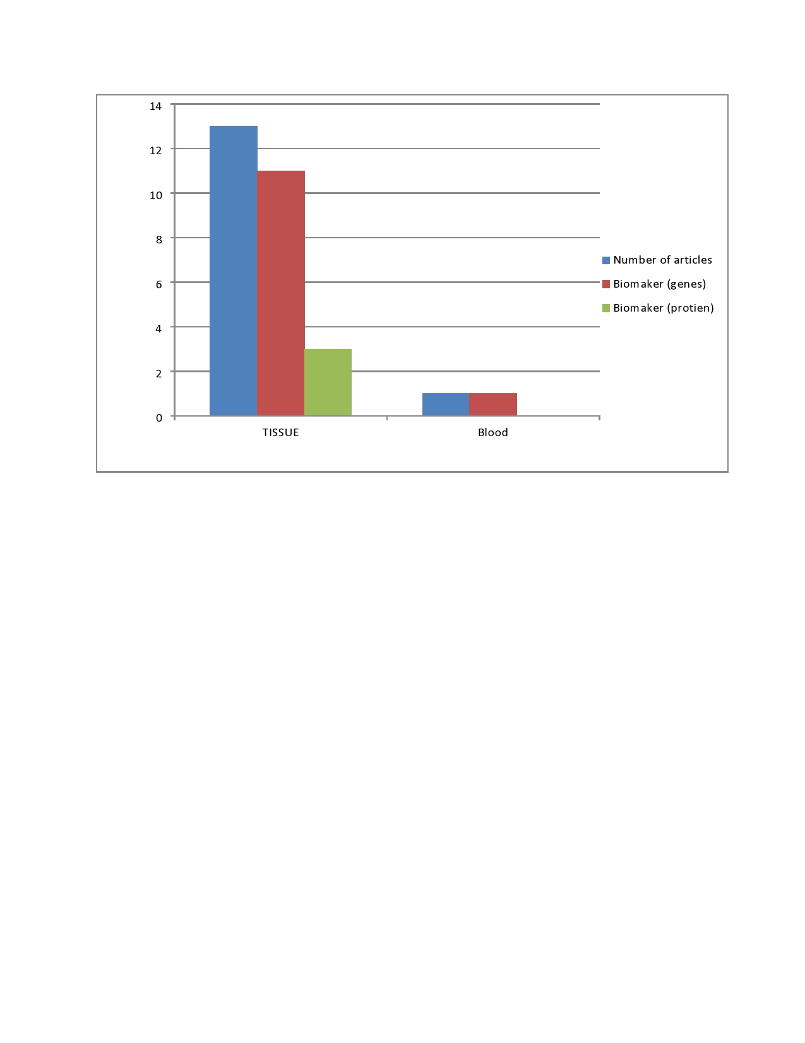

**Figure 4.3 Column chart** (a) Blue color showing the total number of records identifies for the study. (b) Red color representing the genes biomarkers that are present in the tissue. (c) Palm leaf color described the proteins biomarkers that are present in the tissue. Red color below describing the genes biomarker found in the blood.

**4.3 Quality Assessment**

Using the Quality Assessment of Diagnostic Accuracy Studies (QUADAS)-2 tool, reviewers Umar Muhammad BASUG/UG/BHS/ANA/18/133 and Aliyu Adamu Ahmad BASUG/UG/BHS/ANA/18/054 separately assessed the Risk of bias RoB of the included publications. In two trials, the QUADAS-2 tool's reproducibility was tested (Whiting et al., 2011)

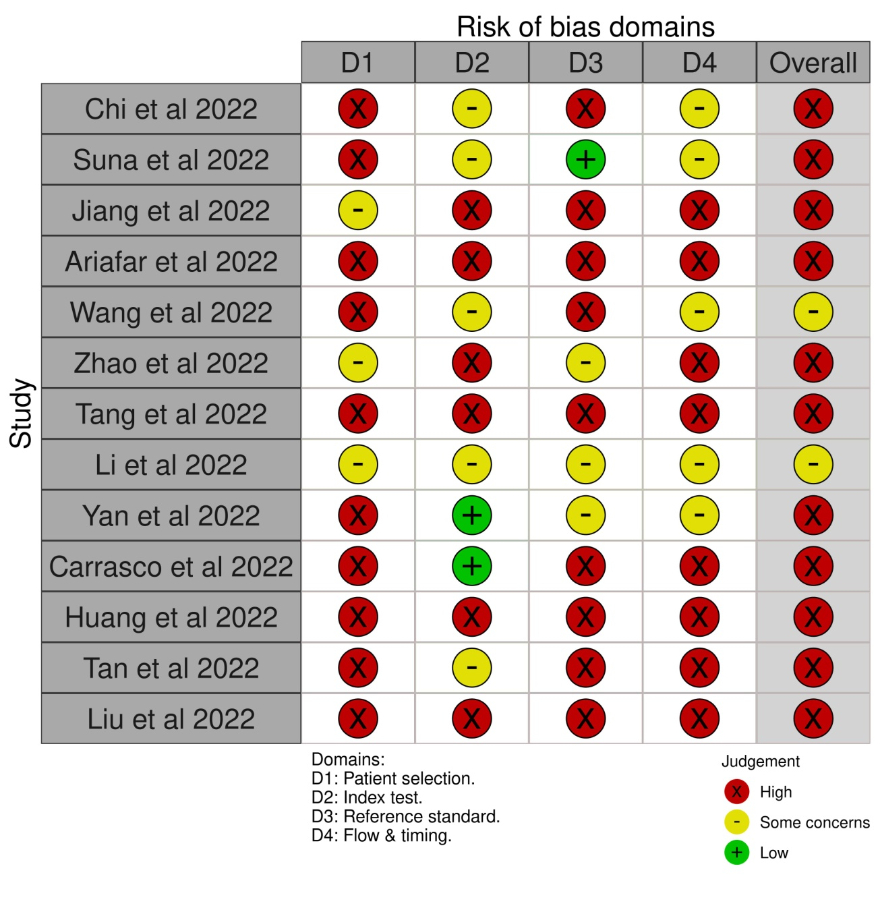

**Figure 4.3** Explanation of RoB and issues with applicability as according to QUADAS-2.High RoB was rated for patient selection in 11 trials. Some concerns were rated for 2 trials. Low were rated for 3 studies.